Development of a Smart Parking System with Cashless Payment Integration
Bryan Jonatan
Computer Science Department,
School of Computer Science
Bina Nusantara University
Jakarta, Indonesia 11480
bryan.jonatan@binus.ac.id

Vinsensius Justhin
Computer Science Department,
School of Computer Science
Bina Nusantara University
Jakarta, Indonesia 11480
vinsensius.justhin@binus.ac.id

Alvina Aulia
Computer Science Department,
School of Computer Science
Bina Nusantara University
Jakarta, Indonesia 11480
alvina.aulia002@binus.ac.id
Septonio De Milliano
Computer Science Department,
School of Computer Science
Bina Nusantara University
Jakarta, Indonesia 11480
septonio.milliano@binus.ac.id

Abstract— A few developments had been made to improve parking systems but still has issues such as reliance on physical item and user intervention. This study aims to create a prototype of parking system that use LPR (license Plate Recognition) detection system integrated with automated cashless payment mobile application called Parkys with the intention to solve issues faced by current conventional parking system such as long queues and cash-based payment. This parking system was developed using Waterfall process. Result data is gathered by testing the developed parking system and gathering user feedback through questionnaire with demonstration video of the developed parking system. Based on the testing of the developed prototype of Parkys Parking System and the survey that is conducted, the result show that the system has potential to be operational and has high acceptance from survey respondents. It can be concluded that Parkys Parking system is operational and has high potential to be accepted in public use with more development.
Keywords—mobile application, license plate recognition, parking system, cashless payment

Introduction
Digital technology is rapidly developing over time and making an impact on the Indonesian parking system. The conventional parking systems typically required users to take an entrance ticket from the entrance machine and pay the parking fee using cash as a form of payment at the exit gate. Turns out, this conventional parking system has many weaknesses. Research on payment methods found that paying using cash handling or physical card tapping at exit gates is the primary contributor to traffic congestion and user dissatisfaction [1], [2]. This has caused a growing demand to develop and transition towards seamless and contactless parking systems.
A few developments to break this problem are implementing IoT-integrated systems and cloud-based monitoring [3], and some recent studies created smart parking systems implemented with AI to gather data in real-time space monitoring and automated billing, with the result showing improvement of traffic efficiency, especially in urban environments [4], [5]. However, these solutions are either not widely implemented or still dependent on physical items such as RFID cards or paper tickets and still require manual user intervention such as scanning QR codes for payment [6]. Albeit an improvement over conventional parking systems, these solutions still fail to deliver a fully automated experience. This was caused by the reliance on external physical media that pose risks of loss or damage to the physical item while manual scanning processes prevent the realization of a truly “free-flow” exit mechanism.
To address these constraints, recent research and advancements have investigated a potential solution through the implementation of License Plate Recognition (LPR) and other high-efficiency technologies that use edge computing devices that have shown promise in identifying vehicles in real time at a low cost as a possible option to replace physical ticket [7], [1]
The goal of this study is to combine License Plate Recognition (LPR) technology with cashless payment by making a prototype for a smart parking system. This prototype system will be built using distributed architecture. When a vehicle is detected, an automatic payment will be made on the server side through a mobile app. The system will use a RESTful service architecture to make data exchange more efficient, and it will not focus only on LPR or IoT monitoring systems [8]. This approach is different from earlier studies and developments that focus on LPR accuracy and IoT monitoring separately. This prototype is designed to demonstrate hands-free parking and seamless automatic billing.

Related Works

License Plate Recognition and Detection
“License Plate Detection and Recognition” was developed to capture images from moving vehicles, detecting the license plate and recognizing the plate’s characters simultaneously [9], and to improve the accuracy, especially in different conditions, the system can also implement “Optical Character Recognition” (OCR) [10].

System Architecture and Data Communication
Smart parking systems development requires architecture that can handle data exchange between devices, databases, and user interfaces, with a study pointing out that there are multiple approaches to smart parking systems with different smart parking systems utilizing different sensors, networking technologies, and more [11]. A study found out that a parking system using real-time vehicle detection integrated with automated transactions and cloud-based data processing can overcome queueing issues caused by cash handling and show improvement in user comfort and parking experience. [12]
The communication efficiency between the user interface and the database is highly dependent on the protocol used. Farrabi et al. (2025) evaluated that RESTful-based services provides the high performance required for cashless parking payment applications on mobile devices. This data transmission speed is crucial because transparency and ease of use of the application are key factors that drive user willingness to adopt a digital parking payment system. The integration between a responsive backend and a mobile application creates a positive correlation with user satisfaction in a smart parking ecosystem. [7] On the hardware side, vehicle identification system implementation is shifting to more efficient edge devices. Raspberry Pi, as an IoT-based model for license plate recognition, offers a low-cost yet effective solution for smart parking systems. Furthermore, the use of deep learning technology on edge devices enables real-time license plate recognition with high efficiency. By processing images directly on the local device (Raspberry Pi), the workload on the central server can be reduced, thereby accelerating the system workflow from detection to automatic gate opening.

Non-cash Payment and User Satisfaction in Smart Parking
A lot of researches has been conducted in order to solve payment problems in improving the parking system. One of these research resulted in development of a parking system using IoT architecture which integrate the transactions in the system which showed result improvement in the efficiency of parking systems especially in busy areas [12]
Another study also found out that non-cash parking payments are preferable by users because of its flexibility and ease of use. It can be concluded that non-cash payment mechanisms can raise user satisfaction in using smart parking systems which potentially give more reasons to further research of smart parking solutions. [3]

Iot Devices
Authors in [13] and [14] developed a low-cost smart parking system using an IoT device known as Raspberry Pi to run an OCR algorithm coupled with a camera to capture the vehicle's license plate number, and in [2], the authors created a QR-based template-matching parking system using an IoT device known as Arduino coupled with a camera in order to detect and capture a vehicle.
These studies showed that the Raspberry Pi and other comparable low-cost IoT devices may be readily utilized to run OCR algorithms without requiring a lot of computing power to recognize vehicles and collect vehicle license plates, with the extracted data then transmitted to a database for storage.

Comparison of Similar Systems
- Comparison of Similar Systems from previous studies with Parkys Parking System
Study/system | LPR | IoT | Cashless | Mobile App | Edge Device
[12] | ✗ | ✓ | ✓ | ✗ | ✗
[13] | ✓ | ✓ | ✗ | ✗ | ✓
[14] | ✓ | ✓ | ✓ | ✗ | ✓
Parkys | ✓ | ✓ | ✓ | ✓ | ✓
As shown from table 1, previous studies tend to focus on development of one specific components of smart parking system while parkys combined all of major components into a unified architecture which constitutes this study primary novelty.

Research methodology

Method of Collecting Data
Both quantitative and qualitative methods will be used in this study where literature review of relevant academic literatures was conducted to establish the theoretical foundation, and the survei distributed via social media in order to identified issues of current parking systems and user expectations of the proposed system design , where the results are being used as guidelines for developing a system that meets user needs.
Survey participants inclusion criteria consisted of individuals aged 17 or older and have experienced in using parking facility in the last 6 months while the exclusion criteria consisted of no prior parking experience and duplicate submission. These criteria are meant to ensure the collected data represents opinions of individuals familiar with conventional parking system and its issues.

Proposed System Architecture
We develop a parking system that combines computing on the edge and a centralized backend. This ensures that payments process automatically and everything runs smoothly. The explanation of our system is explained below:
- Computing on the Edge (Hardware)
We use a Raspberry Pi 4 Model B on the parking gate that has a USB webcam to do the license plate recognizing (LPR). The device uses a library like Tesseract and OpenCV to scan and recognize the license plate.
- Backend and Database
We build our backend using C# programming language and Microsoft Visual Studio 2022. The backend is connected to the database for all the users in our application. The information that is stored in the database includes important things such as usernames, emails, passwords, vehicles, balances, and many more. For the database, we use SQL Server Management Studio to manage our data.
- Frontend Interfaces
We divided the frontend interfaces into web applications and a mobile application. The web application built using React and is made for parking admin who manage parking areas and admin that control the entire parking system. Meanwhile the mobile application that was built for users who use the parking area to park their vehicle where user can manage their data including but not limited to vehicle data, parking history, vehicle management and make a payment inside the application.

Software Design, Development and Analysis Method
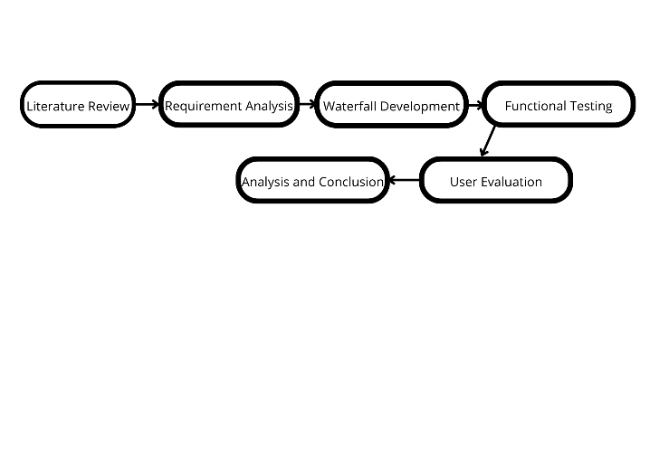
- Research Framework
This study follows the research framework as shown in Fig. 1. consisting of literature review, requirement analysis, waterfall development, functional testing, user evaluation, and result analysis. This study implemented the Waterfall software development approach because of its orderly structure and clean documentation process. The phases are executed as follows:
- Communication : Conducting surveys and literature reviews to gather user requirements and identify problems in current existing parking systems.
- Planning : Identifying main features, estimating timeline schedules, and selecting the technological frameworks based on the gathered requirements.
- Modelling : Designing the system architecture, Entity-Relationship Diagram (ERD) for the database, backend behaviour, and user interface (UI) wireframes.
- Construction : Developing the system based on the models created from the modelling phase; this includes creating the database, the backend logic, and APIs; building the React/React Native frontend systems for both users and parking gate simulations; configuring the Raspberry Pi LPR module using tesseract; testing functions; bug fixing; and design iterations for better navigation.
- User Final Survey : Instead of a full deployment, this final phase is substituted by an evaluation survey where prospective users are provided with a recorded video demonstration of the application. Users then complete a survey to provide their opinion on whether the system fulfils their requirements and solves the initial problems. Since the system has not yet been deployed in a real parking environment, the evaluation focuses on user perception rather than operational performance.

Limitations
Due to limited time and budget in making of this study, The Parkys parking system is still a prototype and cannot reach deployment phase causing it cannot be tested by users in a real parking environment and it cause data or metrics such as LPR accuracy, processing time, bugs or error from app and web cannot be collected. The evaluation survey, which consists of application demonstration videos and structured questions focuses on user opinion and acceptance level, replaces direct operational effectivness in real-life field testing. The survey participants themselves are not separated between mobile users and parking lot owners or parking operators. this limitation may cause inaccuracy the results of the survey and conclusion of the study by self reporting data and the hardware’s endurance in various environmental conditions.

Result and discussion

System Implementations
This section presents the realization of the proposed system architecture, detailing the functional components developed and integrated to form the Parkys smart parking ecosystem.
1. Front-End
The front-end consisted of a cross-platform mobile application that was developed with React Native framework and websites that were developed with Next.js framework. The mobile application takes on the role as the primary interface for end users, successfully translating the initial UI/UX designs to a functional application. The mobile application allows users to seamlessly register their vehicles, view parking history, top-up balance, monitor real-time parking information, and do the manual payments inside the app. By utilizing React Native, the application ensures high responsiveness and a consistent user experience.
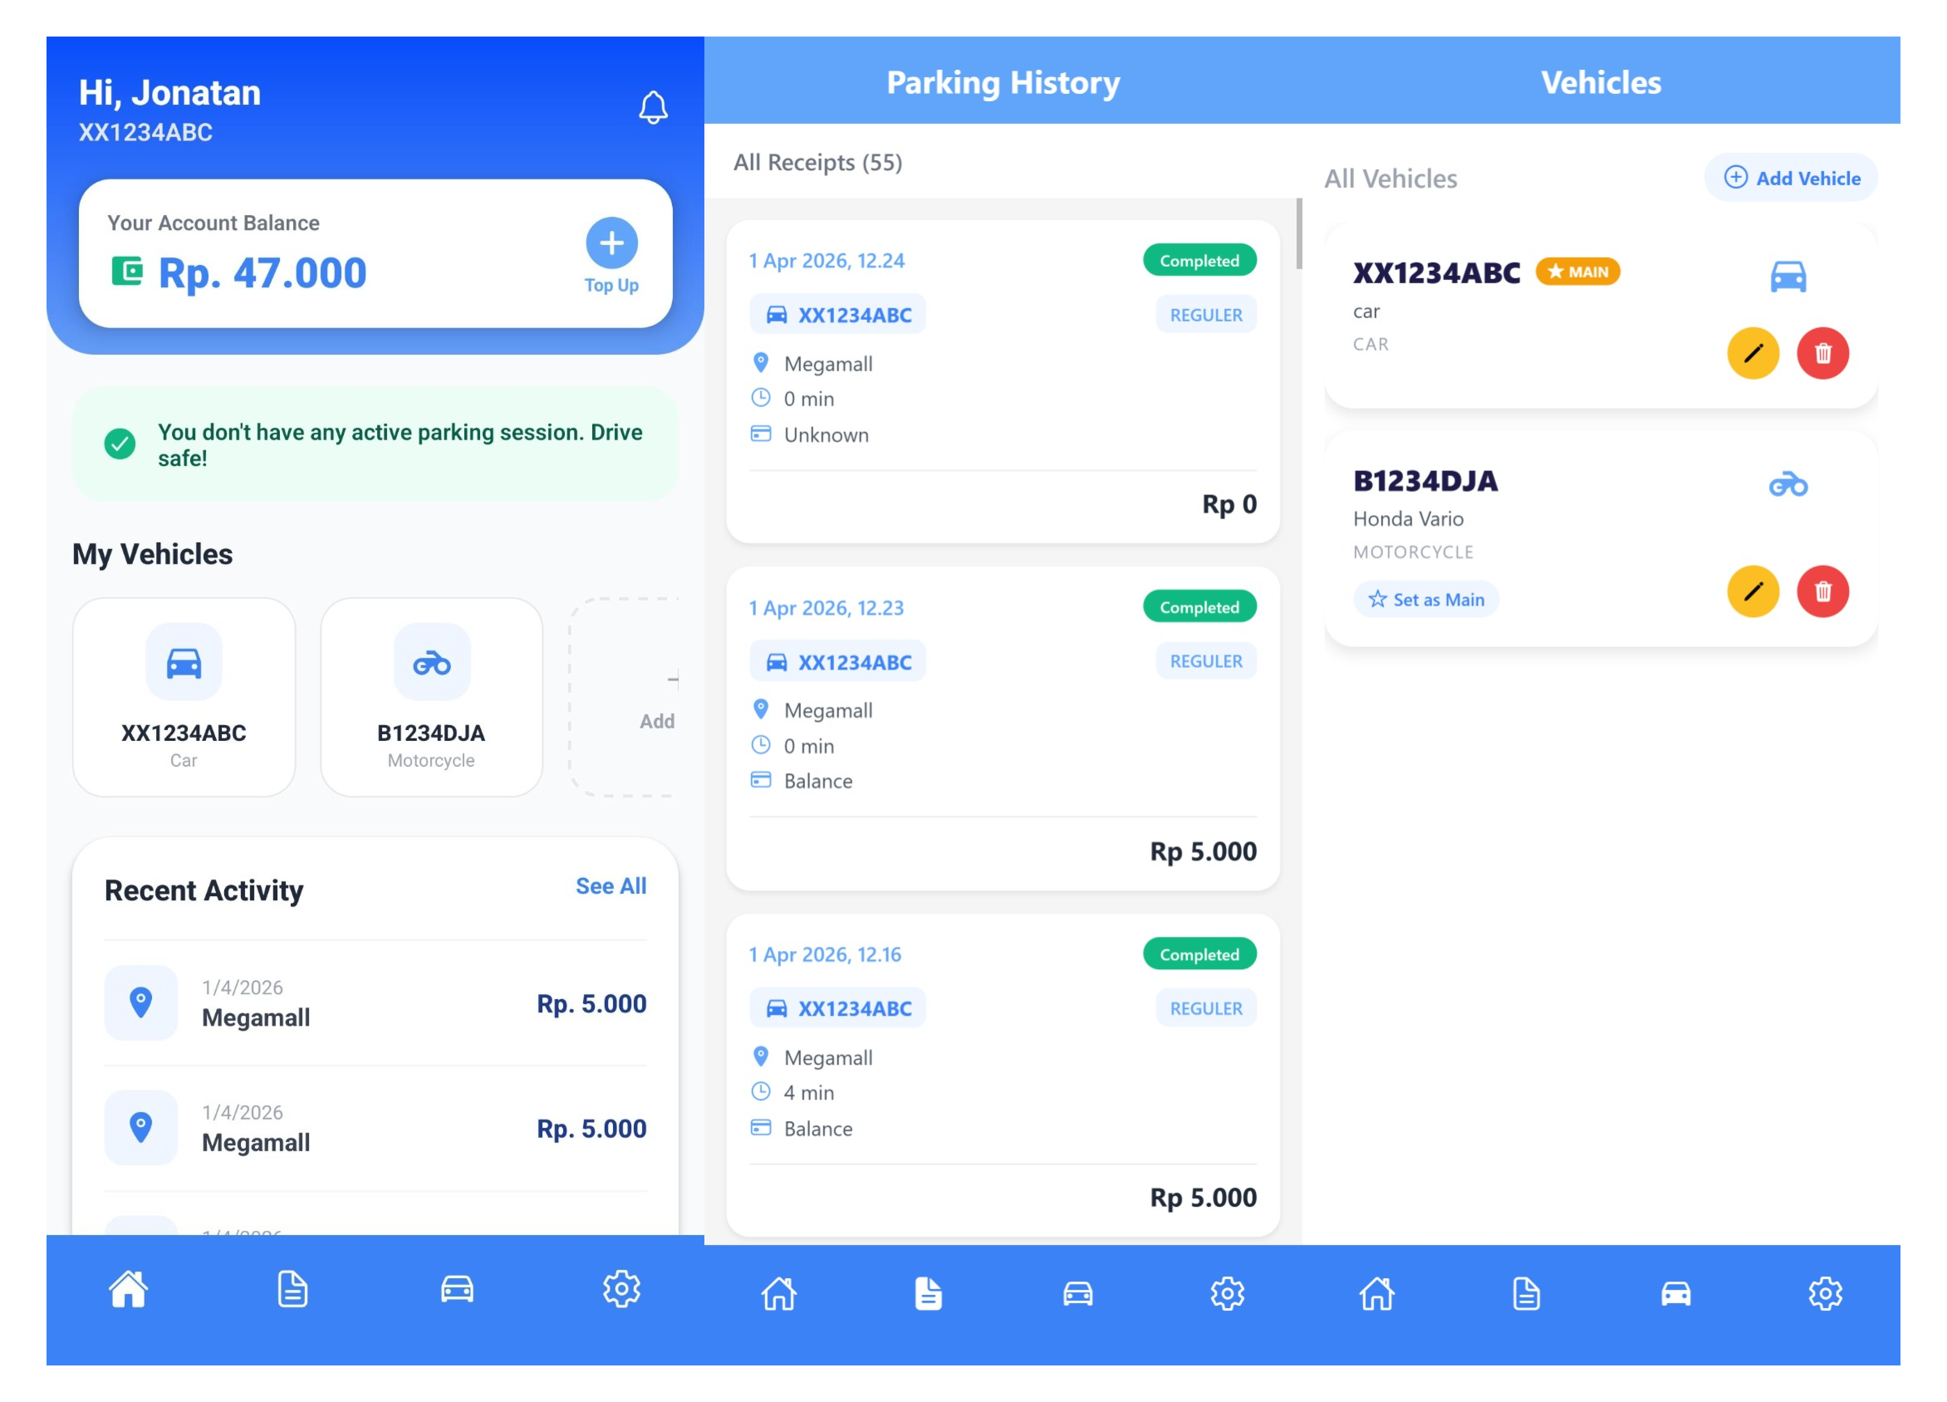
- Parkys Mobile Application Interface: (a) Home Page, (b) Parking History Page, (c) Vehicle Page
There are 2 websites that were developed for users which are Admin Website and Parking Admin Website. Admin Website is for users with “Admin” role to control the parking system entirely such as regulate user data including creating new Parking Admin and monitor the parking rates. Parking Admin website is for users with “Parking Admin” role that regulates parking activity in their own parking lot including managing parking rates or fee. The website allows both Admin and Parking Admin to view real-time data of parking activity (Parking Admin website only show parking activity data from parking lot that was managed by the parking admin).
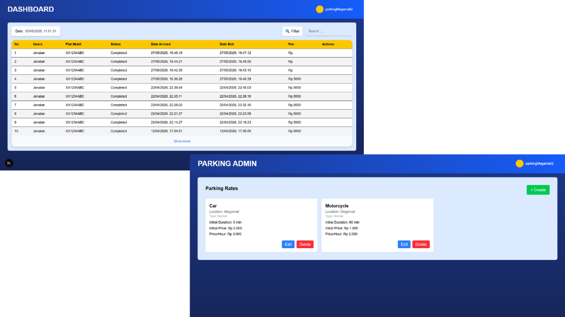
- Parkys Parking Admin Website interface: (a) Dashboard Page with parking data list, (b) Parking Rates Page
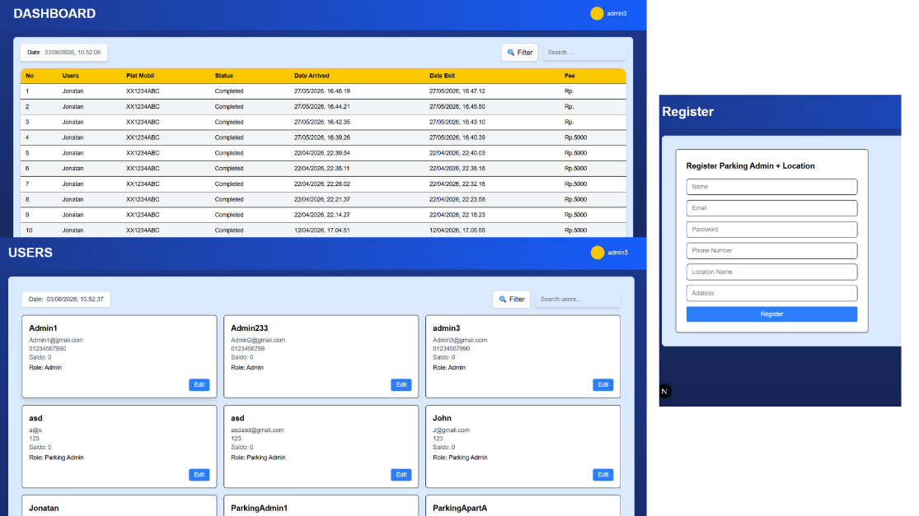
- Parkys Admin Website interface: (a) Dashboard Page with parking data list, (b) user page with user list, (c) Parking Admin Registration page
2. IoT Parking Gate Simulation
A website for parking gate simulation has been made from HTML CSS JS and python with tesseract OCR library for plate recognition. Tesseract OCR is implemented due to its capability recognize different font types and text size, has high accuracy in scanning low quality images and have the capability to be trained in specialized format and has been used in multiple [14] research or studies that required OCR such as developing a reading nutrition labels systems [14] or vehicle plate recognition for developing parking systems such as the system that was developed by author [15].
this website is being used only for simulation of parking gate both for entrance gate and exit gate and displaying parking activity data to see if the data is inserted to database where this website is configured in Raspberry Pi device coupled with a webcam
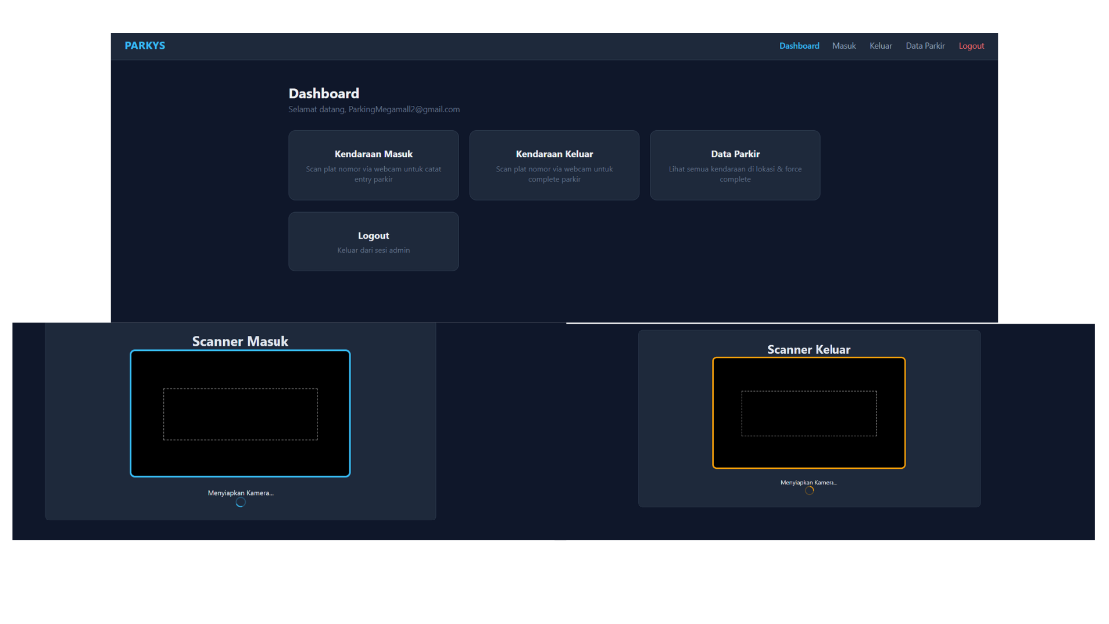
- Parking Gate Simulation Interface for Testing Purposes: (a) Dashboard page, (b) Entry gate page, (c) Exit gate page
3. Back-End
Backend systems act as the central processing hub of the system architecture, which was developed using the C# .NET framework. It exposes RESTful APIs that take the role as the secure communication bridge between the hardware (Raspberry Pi), mobile and web application (front-end), and the database. The implemented backend successfully handles complex business logic, including receiving the text data from the License Plate Recognition (LPR) module and calculating parking durations and fees based on the entry and exit time. and processing the automated payment systems. The high-performance of C# .NET ensures minimal latency during data transmission, which is critical for a hands-free parking experience
4. Database
The database's role is to store important data such as user profiles, active parking data, parking rates, parking type and other essential data where in this research, SQL server was implemented because it's easy to use, using structured SQL query and can support retrieval data for real-time updates like for active parking data and other task.
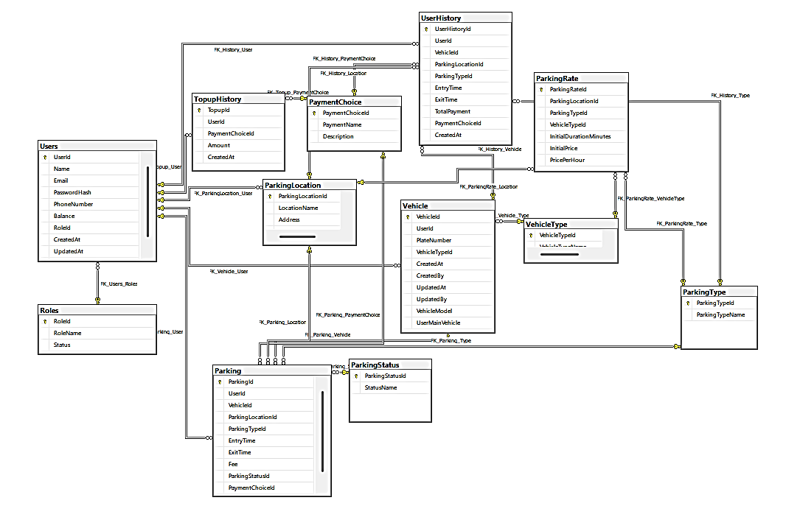
- Entity Relationship Diagram of Parkys

Functional Overview
In the parking system there are 3 user roles which are “Admin”, “Parking Admin” and “User”. Admin role can access entire parking and user data, Parking Admin role can access parking data in the parking location that is regulated by the Parking Admin user, User role can register their vehicles, view parking history, top-up balance and more.
From system implementation descriptions from above, it can be concluded that the features that was developed have met user needs that were identified through other studies and research in the planning phase.

Functional testing

For the testing of Parkys Parking System, we test each essential function and then we put combined test of all essential functions altogether in one test flow. This testing includes user authentication, navigation, CRUD (Create, Read, Update, Delete) operation like Register new account or update profile and to have consistency we test the this functions with multiple users with different roles.

Testing results indicate the essentials functions has performed as expected albeit with minor bugs on the Front-End Elements such as inconsistent formatting for different mobile device sizes and a rare occasion of different scan results of vehicle plate number from parking gate simulation. In overall, the developed parking system has achieved full functionality based on the testing.

User Survey
In the survey that we conducted with 103 respondents, we ask the users to give their opinion which include but not limited to agree-disagree question (with 1-5 level where 1 means strongly disagree and 5 is strongly agree) of current parking system issues, the offered solution and our Parkys parking system that integrate the offered solution to fix the current parking system issues
- Survey Results About Current Parking System Issues
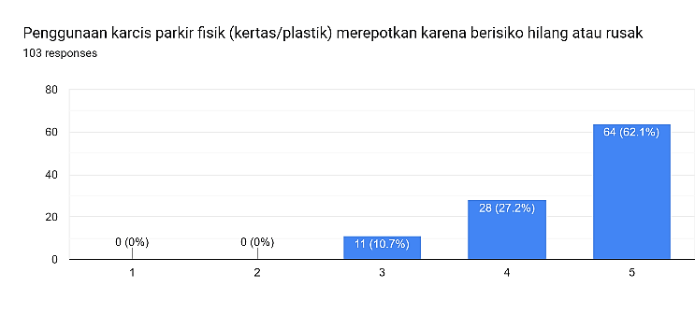
- Conventional Parking System main constraint Survey result where physical ticket has risk of loss or broken
Survey results indicate the main constraint the user face when using current conventional parking systems is the reliance on physical parking tickets due to the risk of loss or damage followed by long queues at the entrance or exit gates , users also face substantial hurdles such as didn’t have NFC feature on their smartphones, it can be concluded that user has strong dissatisfaction which validate user needs of parking system that didn’t rely on physical tickets with integration of automated and cashless payment parking system.
- Survey Result About The Offered Solutions
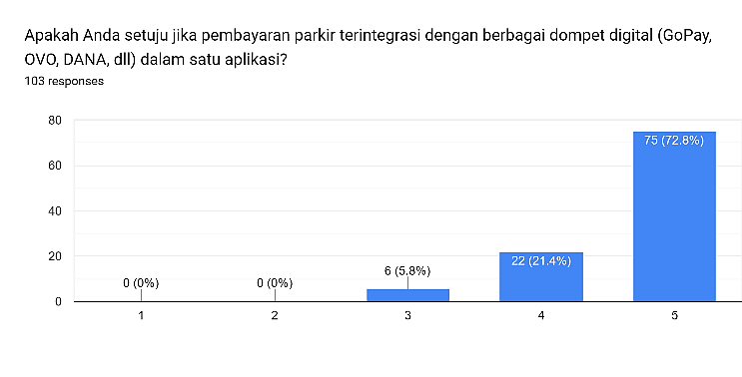
- Major Solution survey result where user prefer integrating digital wallets for parking payment
Survey results indicate the major solution is integration of various digital wallets in one application for parking payments, with the majority of 75 respondents strongly agree, followed 94 positive feedbacks for using automatic license plate recognition (LPR) cameras for parking gate automation replacing physical ticket. Another solution such as parking history features or paying parking fee via an app on smartphones, also presents as substantial solutions. It can be concluded that users strongly agree these solutions have to be implemented in the development of new parking systems.
- Survey result about Parkys parking system
- Mobile Application
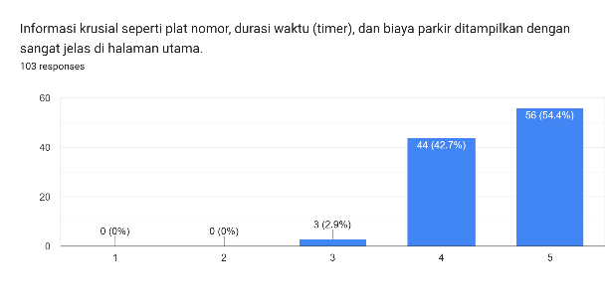
- Mobile Application Survey Result about displayment of crucial information
Survey results indicate Mobile Application gets mostly positive feedback, especially in the display of crucial information as ilustrated by Fig. 8, followed by the payment flow in the mobile application, and overall, the user is interested in using the Parkys parking system.
- Admin Web
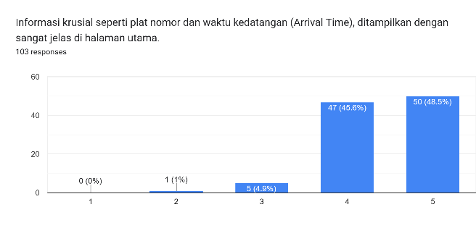
- Admin Website Survey Result on displayment of crucial information
Survey results indicate the website gets mostly positive feedback especially in the displayment of crucial information, followed by the easiness to understand and use of the stages in carrying out each function on the Parkys Admin website
- Parking Admin Web
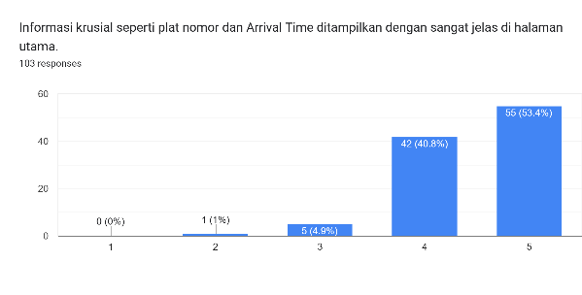
- Parking Admin Website Survey Result on displayment of crucial information
Survey results indicate the Parking Admin website gets mostly positive feedback especially in the displayment of crucial information, followed by the easiness to understand and use of the stages in carrying out each function on the website.

Analysis and discussions
This section discusses results interpretation of system testing and user evaluation, and to validate the Parkys parking system effectiveness using previous studies.
- Efficiency of App-Based Payments on Queues
Preliminary survey results indicate that the main issues is in the use of physical tickets and the lengthy transaction times at the exit gate. Integration of license plate recognition with automated payment gates in our systems, has proven to be a solution to these issues. The transition from conventional payments to an app-based payment aligns with the findings of Oz et al. (2025) [16], confirmed that app-based payment methods significantly reduce transaction times and congestion in parking areas Furthermore, Rosly et al. (2020) [17] demonstrated the effectiveness of payment automation through a mobile app, which replaces physical tickets, by developing the CouponCar app. Therefore, the high user acceptance score for Parkys automated payment feature confirms that eliminating physical interaction is a key factor in improving the parking system.
- IoT Architecture Validation and Real-Time Monitoring
To achieve hands-free experience, the Internet of Things (IoT) architecture, with camera integration, relies heavily on it. The study by Nasim et al. (2022) [18] and Ashok et al. (2020) [19], states that the use of IoT technology and smart sensors integration is an essential foundation for a modern parking system. Also, the availability of mobile and web interfaces on Parkys facilitates precise monitoring of parking and user information. This approach is validated by Mizan et al. (2021) [20] and Mani (2020) [21], where combining IoT with cross-platform applications to provide a real-time data monitoring is crucial for smart parking management.
- Efficiency Level and User Satisfaction
Users gives mostly positive sentiment regarding Parkys app ease of use based on final user evaluation result. This show how user interface design successfully facilitated user transition phase from a manual system to a digital system. This conclusion aligns with the study by Kalasova et al. (2021) [22] on smart parking apps efficiency, where the adoption and user satisfaction are dependent on how the app reduces the complexity of daily operational tasks.

Conclusion
This study successfully developed Parkys parking system to address issues of current parking systems such as reliance on physical ticket and physical payment. This parking system integrates edge computing with centralized backend and cross-platforms experience with capability of real-time License Plate Recognition (LPR) using Tesseract OCR, automated payment and efficient data management where functional testing result indicate the system can operate as expected with minor issues
Survey result showed user dissatisfaction with conventional parking systems and high level of acceptance to the proposed solution. However due to limitations, Parkys remains a prototype without real-world testing where future work should focus on real world test. In conclusion, Parkys parking system shows a potential to improve efficiency and enhance user parking experience through automation and cashless integration

Acknowledgment
The authors thank BINUS University for the academic guidance, to our lecturer supervisor for giving feedback in this study and to all survey participants.

Data availability statement
Parkys Data that has already gathered and used in this study can be accessed through this link : https://bit.ly/4oGDyvP.

Author contributions
- Bryan Jonatan: Development of Parkys backend, Raspberry Pi code,
- Vinsensius Justhin: Development of Parkys mobile application for users.
- Septonio De Milliano: Development of Parkys admin and parking admin web application
- Alvina Aulia: Supervision & Review.

AI acknowledgement
The authors acknowledge limited use of AI for content organization and language refinement. All research, efforts, and conclusion were solely conducted by the authors.

References
[1] S. Abdullah, P. Riana, and A. Putri, “Pengaruh Kualitas Pelayanan, Fasilitas Parkir Dan Sistem Pembayaran Non-Tunai Terhadap Kepuasan Pelanggan Pada PT Securindo Packatama Indonesia Di Mall Living World Denpasar,” Jurna; Ilmu Sos. dan Huk., vol. 4, no. 1, p. 2026, 2026, [Online]. Available: https://doi.org/10.61104/alz.v4i1.3549
[2] E. Lorenza K, R. Ferdian, and D. Yolanda, “Sistem Pembayaran Parkir Non-Tunai Berbasis Mikrokontroler dengan Metode Template Matching,” Chipset, vol. 4, no. 01, pp. 1–12, 2023, doi: 10.25077/chipset.4.01.1-12.2023.
[3] M. M. Ahmadian, P. Beeramoole, D. Baker, and A. Paz, “Retiring meters: a roadmap to encourage wider adoption of parking apps,” Transportation (Amst)., 2024, doi: 10.1007/s11116-024-10553-x.
[4] A. Haile, “AI-Driven Smart Parking : Enhancing Real-Time Monitoring and Automated Billing with IoT Date : February , 2025,” 2025.
[5] E. Jackson, “Smart Parking and Digital Payments : AI-Driven Solutions for Modern Urban Spaces Date : February , 2025,” no. February, 2025.
[6] F. Sonnara, H. Chihaoui, and F. Filali, “Efficient real-time license plate recognition using deep learning on edge devices,” J. Real-Time Image Process., vol. 22, no. 4, pp. 1–15, 2025, doi: 10.1007/s11554-025-01738-3.
[7] D. R. Farrabi, A. Suharjono, and R. Apriantoro, “Performance Evaluation of RESTful Services and AMQP Protocol in Cashless Parking Payment Mobile Apps,” Int. J. Informatics Vis., vol. 9, no. 4, pp. 1356–1362, 2025, doi: 10.62527/joiv.9.4.2798.
[8] U. Ashraf and A. Haile, “Cloud-Integrated Smart Parking: Real-Time Data Processing for Seamless Vehicle Management,” 2025, doi: 10.13140/RG.2.2.16426.32967.
[9] M. C. Wijaya, “Research of Indonesian License Plates Recognition on Moving Vehicles,” EUREKA, Phys. Eng., vol. 2022, no. 6, pp. 185–198, 2022, doi: 10.21303/2461-4262.2022.002424.
[10] A. Sanmorino and Samsuryadi, “A Preliminary Study of Vehicle License Plate Detection and Identification,” Lect. Notes Electr. Eng., vol. 1008, pp. 1–11, 2023, doi: 10.1007/978-981-99-0248-4_1.
[11] A. Fahim, M. Hasan, and M. A. Chowdhury, “Smart parking systems: comprehensive review based on various aspects,” Heliyon, vol. 7, no. 5, p. e07050, 2021, doi: 10.1016/j.heliyon.2021.e07050.
[12] Vikram Pasupuleti, “Smart Parking: A Real-Time IoT System for Automated Monitoring and Billing,” Iconic Res. Eng. Journals, vol. 5, no. 6, pp. 1–11, 2021, [Online]. Available: www.ijfmr.com
[13] M. M. Abdellatif, N. H. Elshabasy, A. E. Elashmawy, and M. AbdelRaheem, “A low cost IoT-based Arabic license plate recognition model for smart parking systems,” Ain Shams Eng. J., vol. 14, no. 6, p. 102178, 2023, doi: 10.1016/j.asej.2023.102178.
[14] T. M. E. Saputra, A. Susanto, and B. J. Carmelita, “Implementation of Tesseract OCR and Bounding Box for Text Extraction on Food Nutrition Labels,” Build. Informatics, Technol. Sci., vol. 6, no. 3, pp. 1403–1412, 2024, doi: 10.47065/bits.v6i3.6107.
[15] M. Ridwan, B. Pratama, A. Faradis, and S. Agustin, “Implementasi Metode Optical Character Recognition (OCR) untuk Deteksi Karakter pada Citra Plat Nomor Kendaraan Bermotor,” Merkurius J. Ris. Sist. Inf. dan Tek. Inform., vol. 3, no. 4, pp. 171–180, 2025, [Online]. Available: https://journal.arteii.or.id/index.php/Merkurius/article/view/938
[16] S. Onen Oz, M. Gumus, and W. Qi, “Coins, Cards, or Apps: Impact of Payment Methods on Street Parking Occupancy and Wait Times,” SSRN Electron. J., 2023, doi: 10.2139/ssrn.4445305.
[17] N. Atifah Hammade, R. Ghazali, S. A. Mostafa, and B. A. Khalaf, “CouponCar: An Android Based Application to Automate the Street Parking Payment,” Fusion Pract. Appl., vol. 6, no. 2, pp. 72–85, 2021, doi: 10.54216/FPA.060205.
[18] S. Nasim, M. Oussalah, T. Outila, and J. Jutila, “Smart Parking System Based on IoT Architecture and Intelligent Sensors,” no. c, pp. 1–6, 2022.
[19] D. Ashok, A. Tiwari, and V. Jirge, “Smart Parking System using IoT Technology,” Int. Conf. Emerg. Trends Inf. Technol. Eng. ic-ETITE 2020, 2020, doi: 10.1109/ic-ETITE47903.2020.457.
[20] A. Z. M. Tahmidul Kabir et al., “An IoT based Intelligent Parking System for the Unutilized Parking Area with Real-Time Monitoring using Mobile and Web Application,” 2021 Int. Conf. Intell. Technol. CONIT 2021, vol. VII, no. Ii, pp. 107–113, 2021, doi: 10.1109/CONIT51480.2021.9498286.
[21] R. Mani, “SMART PARKING SYSTEM USING IOT AND BLYNK APP.” [Online]. Available: https://www.researchgate.net/publication/343602735_SMART_PARKING_SYSTEM_USING_IOT_AND_BLYNK_APP
[22] A. Kalašová, K. Čulík, M. Poliak, and Z. Otahálová, “Smart parking applications and its efficiency,” Sustain., vol. 13, no. 11, 2021, doi: 10.3390/su13116031.
1

